Adriano Santana da Silva - ID: 23163976

Errors Before

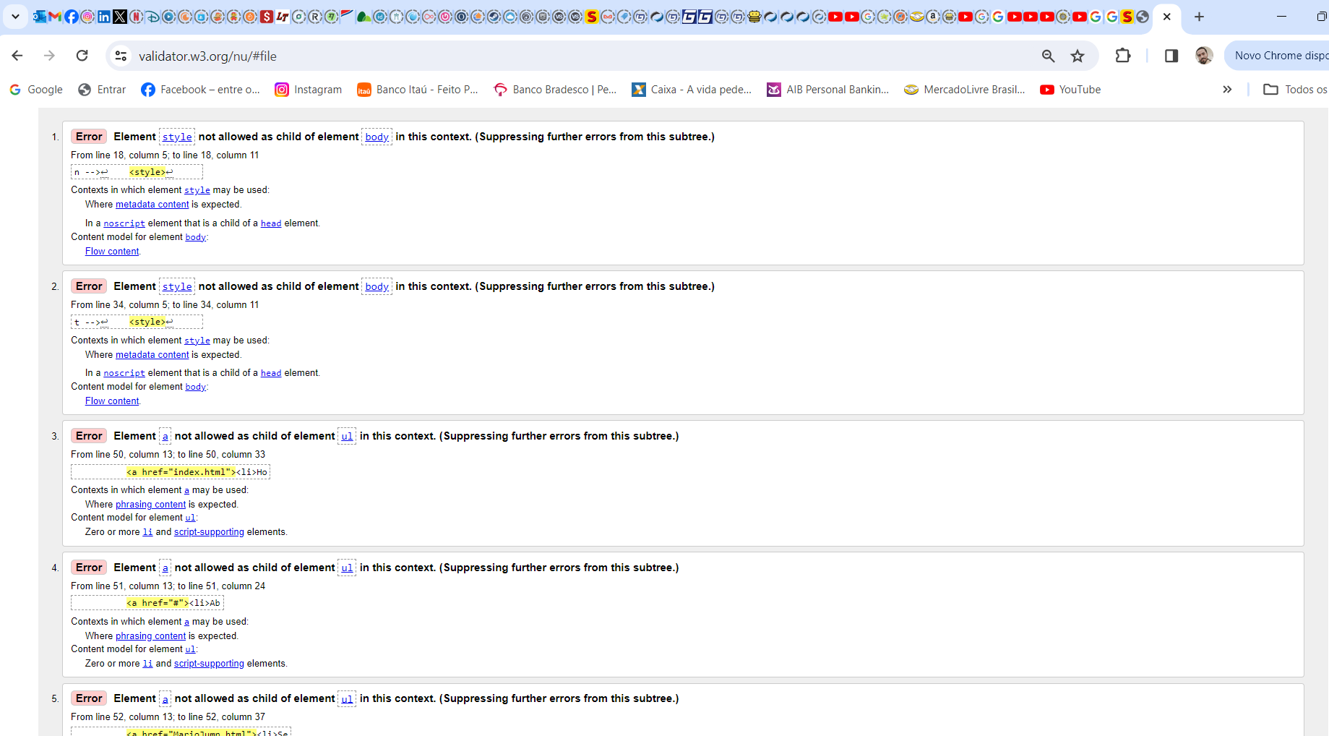

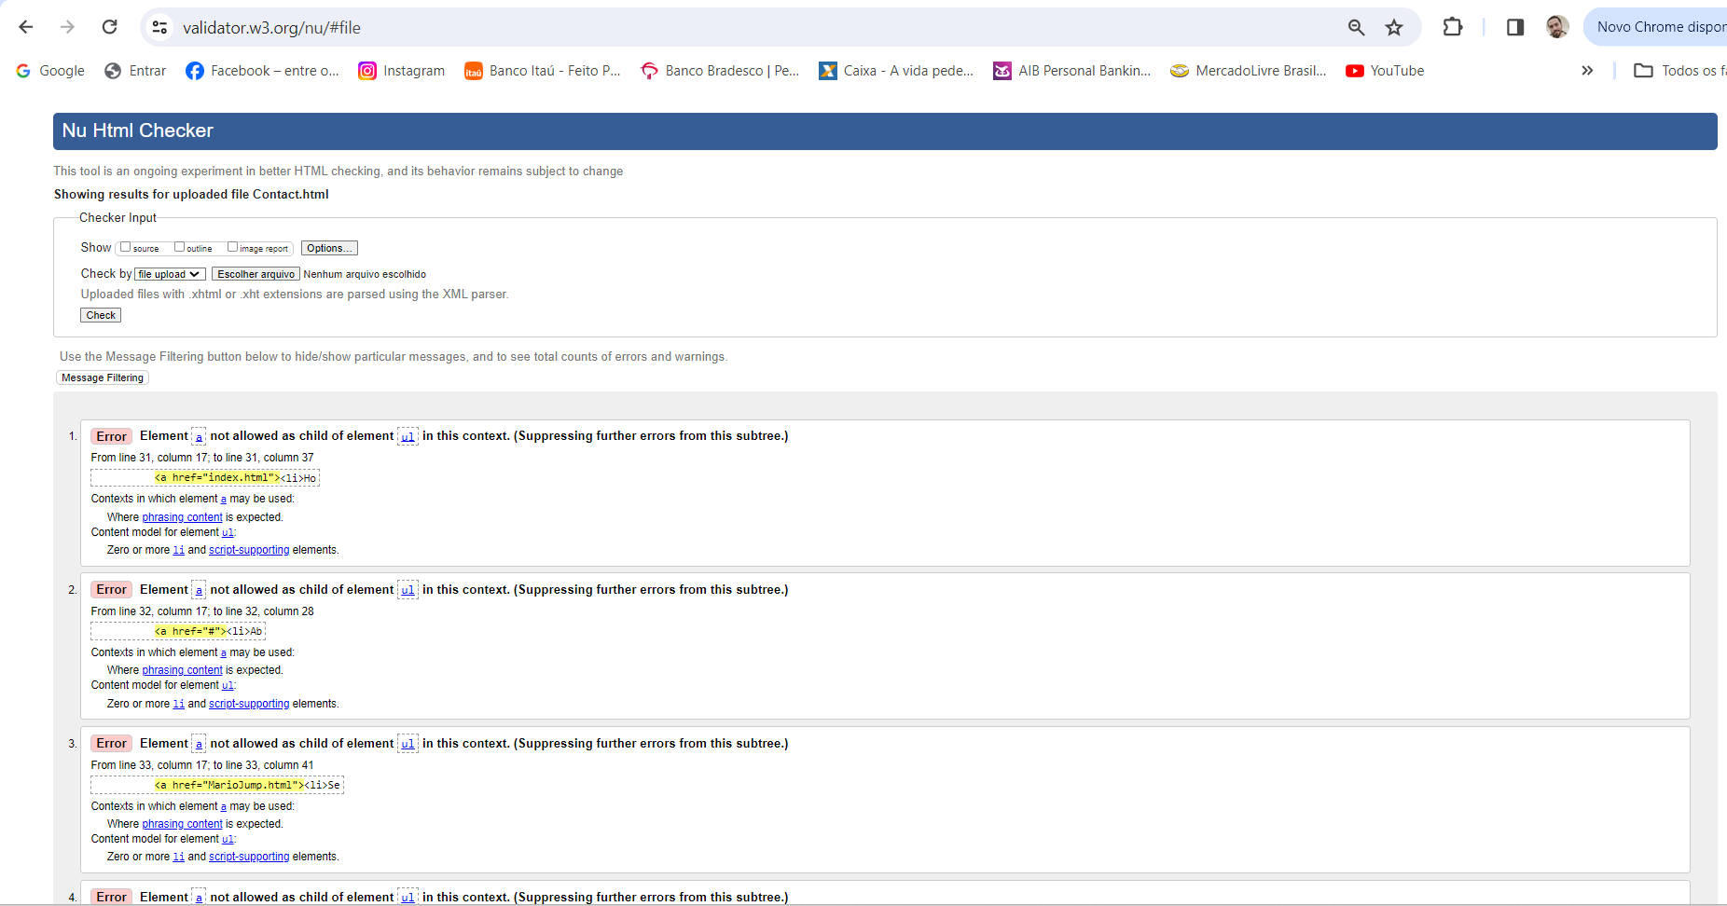

After Correction

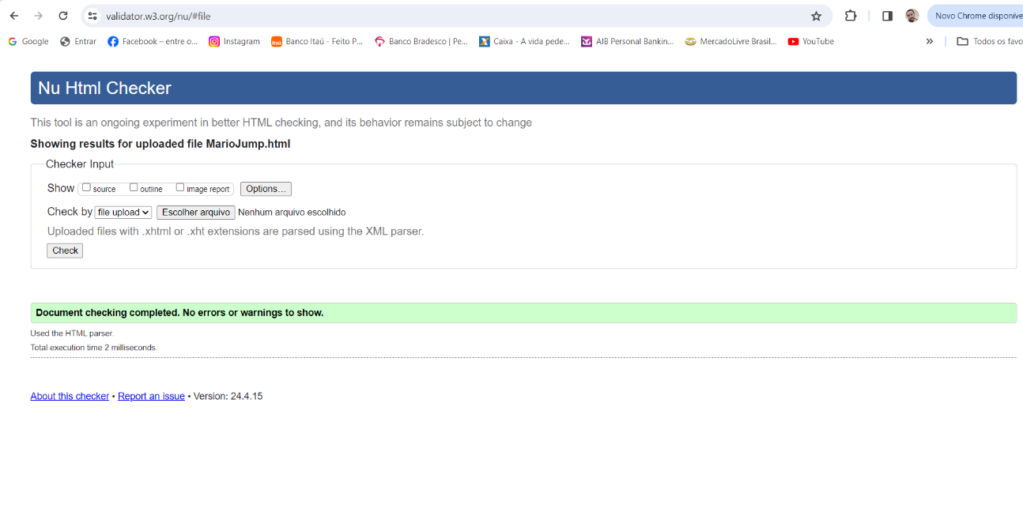

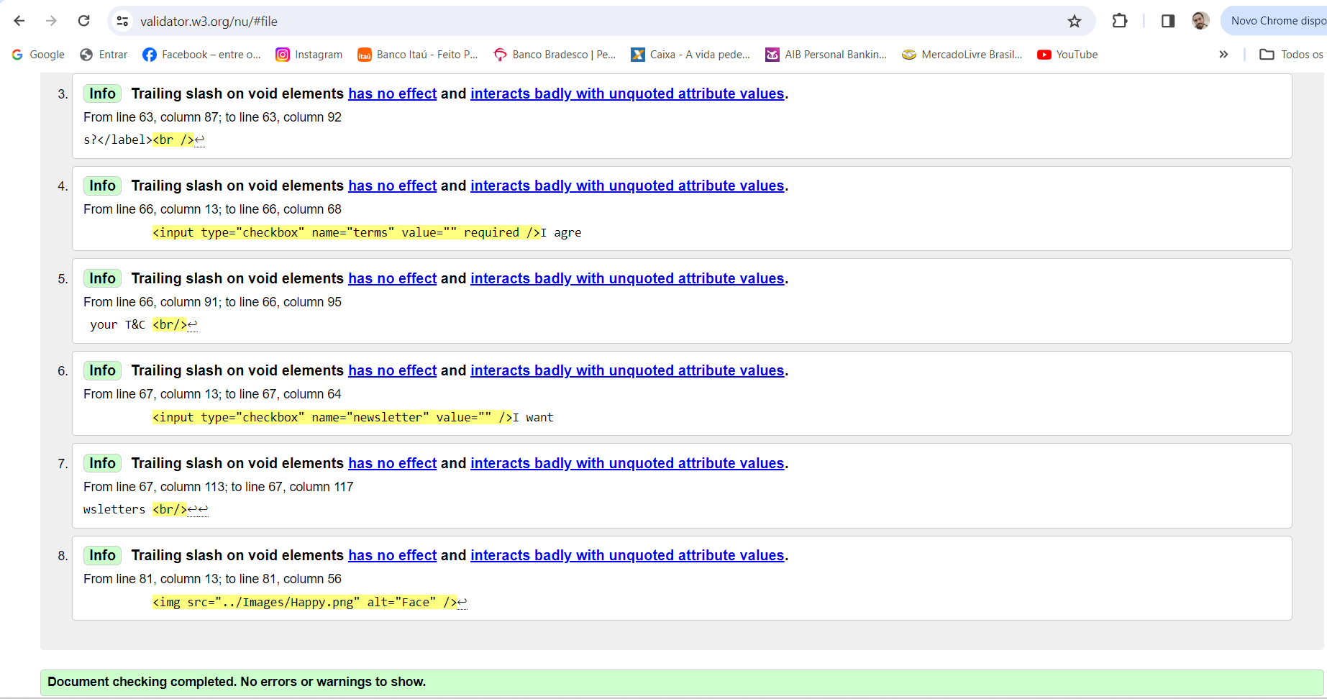

Javascript part

1. **Selecting Elements**: This part of the code selects specific elements from the HTML page. For example, it finds Mario, the pipes, and the restart button. These selections are made using specific CSS classes or element IDs.
2. **Defining Functions**: Several functions are defined to control the game's behavior. For instance, there's a function to make Mario jump, another to run the game loop, one to end the game if Mario collides with a pipe, and another to restart the game.
3. **Game Loop**: The game loop is a recurring process that updates the game's state and renders changes on the screen. In this code, the loop function checks Mario and pipe positions to see if there's a collision. If Mario hits a pipe, the game ends.
4. **Listening for Events**: Event listeners are added to detect specific events, such as key presses and button clicks. When the player presses a key, Mario jumps. When the restart button is clicked, the game restarts.
5. **Starting the Game Loop**: Finally, the game loop is started by calling setInterval, which repeatedly executes the loop function every 10 milliseconds. This keeps the game running smoothly and continuously updates the game's state.

In summary, this JavaScript code controls the behavior of a simple game where the player controls Mario to avoid pipes. It handles user input, updates the game's state, and manages the game's visual elements.

Mario Jump part

1. **Setting Up the Page**: This HTML code sets up a webpage for a game called "Mario Jump." It includes references to external CSS and JavaScript files for styling and functionality.
2. **Page Header**: At the top of the page, there's a header section containing the title and navigation links. The title includes a logo and the name "Code Creatorrs." The navigation links allow users to navigate to different sections of the website.
3. **Game Elements**: The main content of the page is the game board, which includes visual elements like clouds, Mario (the game character), pipes (obstacles), and a restart button. These elements are positioned on the page to create the game environment.
4. **Instructions**: Below the game board, there's an ordered list providing instructions for playing the game. It advises players to use any button to make Mario jump, warns against hitting the pipes, and encourages players to have fun.
5. **Script Inclusion**: Finally, the HTML includes a reference to an external JavaScript file (**script.js**) for implementing the game's functionality. This JavaScript code likely controls aspects like player movement, collision detection, and game state management.

In summary, this HTML code sets up a webpage for a game called "Mario Jump," providing all the necessary elements and instructions for players to enjoy the game experience.

Contact part

1. **Setting Up the Page**: This HTML code creates a webpage for contacting a company called "Code Creatorrs." It includes references to external CSS files for styling and Google Fonts for custom fonts.
2. **Page Header**: At the top of the page, there's a header section containing the company logo and title ("Code Creatorrs"). It also includes navigation links to different sections of the website, such as Home, About us, Services, and Contact us.
3. **Contact Form**: Below the header, there's a contact form where users can input their name, phone number, email, preferred contact method (phone or email), choice of development, additional comments, and subscription preferences. The form includes validation rules to ensure that required fields are filled out correctly.
4. **Thank You Message**: After submitting the form, a thank you message is displayed, indicating that the company will contact the user soon.
5. **Image Container**: There's also an image container displaying a happy face image, likely for visual appeal.
6. **JavaScript for Form Handling**: Finally, JavaScript code is included to handle form submission. It prevents the default form submission behavior, checks if all form inputs are valid, and displays the thank you message if the form is successfully submitted.

Overall, this HTML code creates a user-friendly contact page for interacting with the "Code Creatorrs" company.

CSS Pages Mario Jump and Contact

This CSS code is for styling a webpage, with sections for a game board and a contact form.

For the game board:

* It sets up the board's dimensions, background, and styling for Mario, pipes, and clouds.
* There are animations for Mario's jump and the movement of the pipes and clouds.

For the contact form:

* It styles the form fields, labels, buttons, and thank you message.
* The form fields are arranged neatly with appropriate spacing and styling.
* The header section includes the company logo and navigation links.
* Navigation links have hover effects and are styled for better visibility.
* Finally, there's styling for the overall body of the page, including the background image and layout adjustments for different screen sizes.

In summary, this CSS code ensures a visually appealing and user-friendly design for both the game board and the contact form sections of the webpage.